RF Board Assembly Tips

When soldering the E28 board, smear flux paste onto the pads.

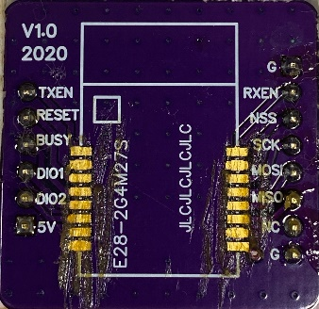

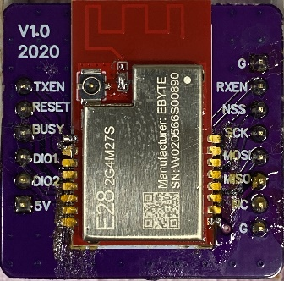Place the E28 module on the board. The flux will help hold the module in place. Put a spot of solder paste on two opposite corners and tack the module in place.

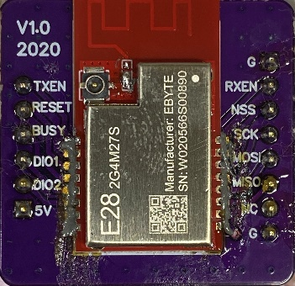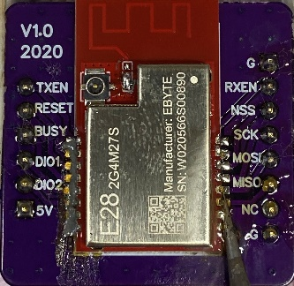Put a bead of solder paste along the pads.

Drag solder ([(42) HowTo: Drag Soldering Demo - YouTube](https://www.youtube.com/watch?v=wUyetZ5RtPs)) the module in place.

Visually inspect your work to ensure that there are no shorts between pads and that you have good, shiny connections at each point.

